**PRACTICAL – 6(6.1)**

**AIM:**

**Write a program using a function to check whether the number is prime or not. (A prime number is a number that has no divisors.)**

**PROGRAM:**

|  |
| --- |
| **num = int(input("Enter the number: "))**  **if num > 1:**  **for i in range(2, int(num/2)+1):**  **if (num % i) == 0:**  **print(num, "is not a prime number")**  **break**  **else:**  **print(num, "is a prime number")**  **else:**  **print(num, "is not a prime number")**  **print("\n20DCE019 - Yatharth Chauhan")** |

**OUTPUT:**

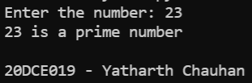

**CONCLUSION:** In this practical we learned about the range operator

**PRACTICAL – 6(6.2)**

**AIM: Write a program that takes a list of numbers (for example, a = [5, 10, 15, 20, 25]) and makes a new list of only the first and last elements of the given list. For practice, write this code inside a function.**

**PROGRAM:**

|  |
| --- |
| **def first_last(a):**  **newlist = []**  **newlist.append(a[0])**  **newlist.append(a[-1])**  **print("First and last Elements of the list are: ", a[-1])**  **return newlist**  **a = []**  **num = int(input("Enter number of elements: "))**  **for i in range(0, num):**  **element = int(input())**  **a.append(element)**  **first_last(a)**  **print("\n20DCE019 - Yatharth Chauhan")** |

**OUTPUT:**

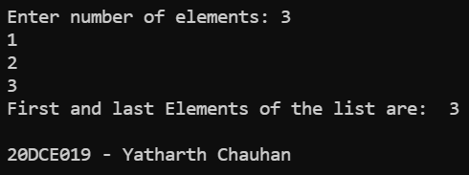

**CONCLUSION:** In this practical we learned about the use of append operator.